Masters Training in Pure Mathematics
The Sida Mathematics project at University of Dar es Salaam under competitive bases won a proposal among the 12 proposals funded by Sida Bilateral programmes of Sweden. The overall goal of this project is to build capacity for graduate training and research in mathematics at the University of Dar es Salaam (UDSM) through collaboration with Swedish universities. The Sida Bilateral programme sponsorship at UDSM was a five years from July 2015 – June 2020 and has been given extension of one year until June 2021.
This project sponsored eight (8) stundents in Masters in Pure mathematics programme. Eight (8) Masters Students are:

Name: Mr. Damas Karmel Mgani
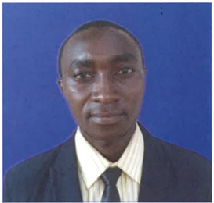
MSc title: On Hilbert Functions and h-vectors of
Graded Modules for Finite Sets of Points in
Projective Space.

Research Description: Investigated the information
attached to Hilbert functions and h-vectors of graded
modules supported on finite sets of points in
projective geometry. These objects have been studied
over the years by different scholars and provided very
interesting results, but there is still a need to
investigate more.

Current status: Mr. Mgani graduated in November 2018.

Email: d.mgani99@gmail.com

Name: Mr. Faustine Nziku

MSc Title: Some Boyd and Wong Type Fixed Point
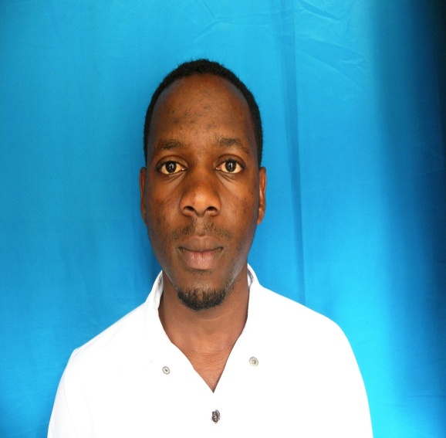
Theorems in Partial Metric Spaces.

Research Description: Investigated some fixed-
Point theorems by generalising the existing Boyd
and Wong type fixed point theorems in metric into
partial metric spaces. This generalisation is
motivated by Mathews (1992) due to his
establishment of partial metric spaces as the
important space to the study of denotational semantics for partially defined programmable data objects to programming languages.

Current status: Mr. Faustine graduated in November 2018.

Email: faustinenziku@gmail.com

Name: Ms. ScolasticaLuambano

MSc Title: Some fixed-point theorems for
F-contraction mappings in partial metric spaces.

Research Description: Extended the Wardowski
fixed-point theorem to partial metric spaces and
study the existing problems regarding
F-contraction mappings in partial metric spaces.

Current status: Mr. Mgani graduated in November 2018.

Email: sholawilgis@gmail.com

Name: Ms. Jesline Eliza Gowele
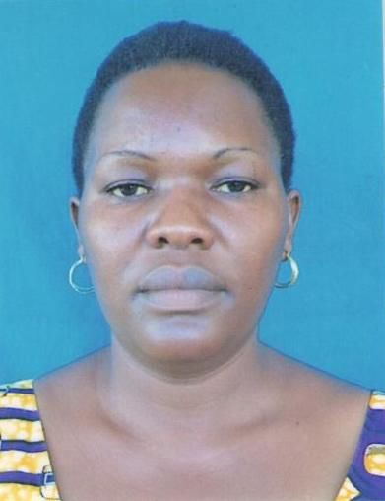
MSc Title: The structure of Lipchitz-free Banach
space (approximation properties).

Research Description: Investigated the
approximation property of a Lipschitz-free Banach
spaces, which is the main property in function
analysis especially in Banach spaces. A lot has
been done but still there are questions, which are
not yet answered.

Current status: Ms. Jesline graduated in May 2019.

Email: gowelejasline@gmail.com

Name: Mr. Richard Osward
MSc Title: Further Investigation on Fixed Points
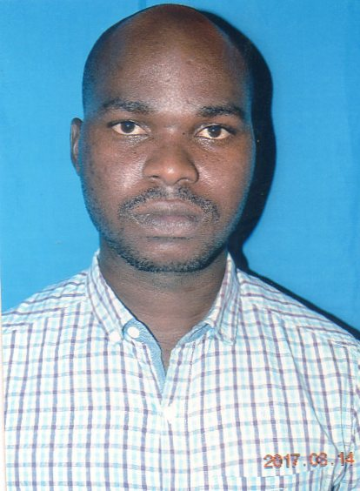
Variational Inequality and Equilibrium Problems

Research Description/Abstract:
We introduce a gradient method to approximate a
common element of the set of solutions of variational inequality problem and the set of fixed points of
an asymptotically non-expansive mapping in a real
Hilbert space. Furthermore, we introduce an iterative algorithm to approximate a common element of the solution set of a generalized equilibrium problem and the set of fixed points of an asymptotically non-expansive mapping in a real Hilbert space. Lastly, we extended the results to a finite family of asymptotically non-expansive mappings. Some applications of the main results are also provided. We our results extend many previously known results in this research area.

Current status: Mr. Richard graduated in November 2019.

Email: ndabhiama1990@gmail.com

Name: Ms. Evelina Wilson
MSc Title: Investigation on some more properties
of ordered sets
Research Description: Investigate some more
properties of ordered sets, particularly the fixed
points, automorphisms and lattices.
Current status: Ms. Evelina graduated in June 2020.

Email: evawilly86@gmail.com

Name: Mr. Edson NzaganyaNzaganya
MSc Title: On the topology of projective
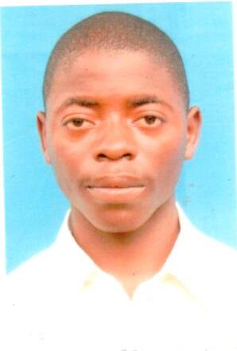
hypersurfaces.

Research Description/Abstract
Discussed the topology of the smooth projective
hypersurfaces. To do this, we start by a tour on
sheaf cohomology and Calculating the cohomology
of the projective space. This is followed by
computing the Euler characteristics of
hypersurfaces via the Griffiths residues. Next, we
attach a vector bundle on the smooth projective hypersurface to define Chern classes. Finally, we invoke the Gauss Bonnet theorem to compute the Euler characteristics of smooth projective hypersurfaces.

Current status: Mr. Edson graduated in June 2020
Email: edsonnzaganya@gmail.com

Name: Ms. Fatma Ali Rashid
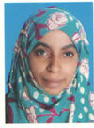
Research Title: Maximal topology

Research description: In this study, we aim at
investigating the information attached to maximal
Lindelöf topology. This has been studied by different
scholars and good results were provided, but there is
still a need to investigate more concern with maximal
Lindelöf topology.

Current status:
Email: fatmaalirashid1@gmail.com

